

RESEARCH SYSTEM PROPOSAL

BLOOD BANK MANAGEMENT SYSTEM.

SUBMITTED BY: SUNDA ESTHER KEMUNTO.

ADMISSION NUMBER: DIT-02-0226/2025.

INSTITUTION: ZETECH UNIVERSITY.

SUPERVISED BY: MR. FELIX WERU.

A RESEARCH SYSTEM PROPOSAL SUBMITTED IN FULFILLMENT FOR PROGRESSION TO THE SYSTEM PROJECT, TO THE DEPARTMENT OF ICT AND ENGINEERING OF ZETECH UNIVERSITY.

SEPT 2025.

DECLARATION
I hereby declare that this Research is my personally undertaken project and my original work.

NAME:SUNDA ESTHER KEMUNTO

SIGNATURE:

DATE:

Declaration by the supervisor;

NAME:MR FELIX WERU

SIGNATURE:

DATE:

ACKNOWLEDGEMENT.
I want to express my sincere thanks and appreciation to all those who provided me with guidance, encouragement, and support in completing this report, especially my supervisor, Mr Felix Weru. A million thanks to him for giving me the chance to complete this project; his patience in guiding and his idea suggestions were crucial factors in the entire project.

Table of Contents
Table of Contents iv
CHAPTER ONE: INTRODUCTION. 1
1.1 Introduction 1
1.2 Background of the Study 1
1.3 Problem Statement 1
1.4 General Objectives of the Study 1
1.4.1 Specific Objectives. 1
1.5 Research Questions. 2
1.6 Significance of the Study. 2
1.7 Scope of the Study. 2
1.8 Limitations. 2
CHAPTER TWO: LITERATURE REVIEW. 3
2.1 Introduction 3
2.2 Understanding Blood Bank Management System 3
2.3 Existing Blood Bank Management Systems 4
2.4 Challenges with the Current System 4
2.5 Role of Security and Data Privacy 4
2.6 Gaps Identified in the Literature 4
2.7 Summary 5
CHAPTER THREE: METHODOLOGY 5
3.0 Introduction 5
3.1 Target Population 6
3.2 Requirements Gathering 6
3.3 Research Design 6
3.4 System Design 6
3.5 Development Tools and Technologies 6
3.6 Testing 6
3.7 Deployment. 7
3.8 Summary. 7
CHAPTER FOUR: SYSTEM DESIGN AND IMPLEMENTATION 8
4.1 Introduction to Implementation and Testing 8
4.2 System screenshot 8
4.3 Testing of the system 11
4.3.1 Unit Testing 11
4.3.2 Integration Testing 11
4.3.3 User Acceptance Testing (UAT) 11
4.3.4 Security Testing 12
CHAPTER FIVE: SUMMARY 12
5.1 Conclusion 12
5.2 Problems encountered 12
5.2.1 Technical Challenges 12
5.2.2 Operational and Scope Limitations 13
5.3 Recommendations for Future Work 13
5.3.1 Development of a Mobile Application 13
5.3.2 Automated Blood System and Integration 14
References 14

ABSTRACT.

DEFINITION OF KEY TERMS

CHAPTER ONE: INTRODUCTION.

Introduction

To save lives during surgeries, accidents, childbirth, and for patients with long-term illnesses, including cancer and anaemia, blood is a crucial part of healthcare. This is why it is important to handle blood donation, testing, storage, and distribution effectively. Errors, inefficiencies, and delays in fulfilling urgent demands are common outcomes of traditional blood bank operations that depend on human recordkeeping. As technology develops, there is an increasing need to automate blood bank procedures in order to enhance communication between blood centres, hospitals, and donors. In order to expedite blood collection, inventory management, and hospital demands, this study suggests a safe, web-based Blood Bank Management System that incorporates mobile access.

Background of the Study

Hospitals frequently utilizes blood transfusion services. Many hospitals and blood centres continue to rely on outdated paper-based methods for registering donors, tracking blood, and managing storage. These methods are prone to mistakes, redundant data entry, and inefficient record retrieval. The World Health Organization reports that delays in finding suitable blood units lead to avoidable deaths, particularly in emergency scenarios. Consequently, having dependable information regarding blood availability and donor suitability is crucial. In recent times, digital systems have revolutionized healthcare record keeping, facilitating the immediate exchange of data, automatic alerts, and better decision-making. The adoption of a web-based blood bank system that includes mobile communication capabilities can boost donor involvement, improve collaboration with hospitals, and guarantee the prompt delivery of safe blood to patients. Furthermore, incorporating data privacy and system security measures safeguards sensitive medical data from unauthorized access.

Problem Statement

Many blood banks still rely on manual processes to manage donor information, blood inventory, and hospital requests, leading to inefficiencies and inaccuracies. This project aims to develop a secure, web-based system that automates these processes, improves data accuracy, and enhances the overall efficiency and safety of blood bank operations.

General Objectives of the Study

To develop a secure, web-based Blood Bank Management System that enhances the efficiency of blood donation, storage, and distribution processes.

1.4.1 Specific Objectives.
- To develop a secure web-based blood bank management system.
- To capture personal details, blood type, donation history, and eligibility status.
- To monitor available units by blood type, quantity, and expiry date.
- To allow hospitals to request blood units and receive timely approvals or rejections.
- To ensure data privacy and system security of the donor and the patient

Research Questions.

- How can a secure web-based system automate and streamline blood bank operations?
- How can the system capture and store donor details, blood type, history, and eligibility?
- How can the system track and monitor blood units by type, quantity, and expiry to reduce wastage?
- What methods can ensure timely approval or rejection of hospital blood requests?
- What measures can ensure data privacy and security for donor and patient information?

Significance of the Study.

This study is significant to several stakeholders in the healthcare sector:
- Hospitals: It will enable efficient access to available blood types and quick approval of requests, improving patient care.
- Blood Centres: It will simplify donor management, inventory control, and real-time monitoring of blood available.
- Donors: It will provide easier registration, donation tracking, and mobile notifications for donation schedules and blood appeals.
- Researchers and Developers: The project contributes to the growing body of knowledge on healthcare automation and can serve as a reference for future research in digital health systems.
Overall, this system aims to improve efficiency, reduce blood wastage, and enhance communication between donors and healthcare facilities while ensuring data security.

Scope of the Study.

The design and development of a web-based, mobile-integrated blood bank management system is the main focus of the study. It includes basic reporting, inventory monitoring, hospital blood demands, and donor registration. The system will not be able to handle laboratory testing or the logistics of blood shipment; instead, it will only manage donor and blood data. The study focuses on data security, usability, and functionality in a networked environment accessible only to authorised persons.

Limitations.

This study is subject to several limitations that may affect the general applicability of its findings:
- The system does not perform or manage laboratory testing of blood units, limiting its use to administrative functions only.
- Transportation, delivery tracking, and physical distribution of blood are beyond the scope of the system.
- As a web-based system, it requires stable internet connectivity, which may be a challenge in some regions.
- The system is designed for authorised personnel only, limiting its usage in wider public health operations.
- Some facilities with outdated infrastructure may face challenges implementing or adopting the system

CHAPTER TWO: LITERATURE REVIEW.

2.1 Introduction

This chapter examines relevant studies on blood bank management systems, including how they function, difficulties they face, and how technology might enhance blood donation and distribution. Understanding current systems, pointing out their flaws, and emphasizing the need for a better, safer, web-based Blood Bank Management System are the goals.

2.2 Understanding Blood Bank Management System

To be able to satisfy hospital needs, blood bank management includes gathering, testing, storing, and distributing blood units. Effective blood management guarantees that compatible and safe blood is accessible when needed which is essential for emergency response and routine medical procedures (WHO, 2021). Request processing, blood monitoring, and donor registration are all integrated with automated blood bank systems. This increases efficiency and transparency through allowing real-time information interaction between hospitals and donors. Besides saving lives, proper blood management enhances healthcare planning and resource usage.

2.3 Existing Blood Bank Management Systems

Many tools have been created worldwide to automate blood management procedures. Examples include the Red Cross Blood Service System, which uses online platforms to assist hospital coordination and donor scheduling, and e-RaktKosh in India, which centralizes donor and blood supply information across multiple hospitals (P & Kulkarni, 2020) .Still, a lot of current systems are built for widespread national or international use, necessitating complex infrastructure and continuous internet connectivity. Smaller hospitals and local donation facilities in developing nations find these methods too costly or complicated to implement.

2.4 Challenges with the Current System

Despite advancements in blood management technologies, (R & Sharma, 2019) several challenges persist. Common issues include a lack of integration between hospitals and donation centres, inadequate data security, and insufficient real-time monitoring. In some systems, donor data privacy is compromised due to weak authentication mechanisms and poor encryption standards. Blood management still faces several challenges despite advancements in digital health systems. A major issue is the lack of integration, where many systems operate independently, making it difficult for blood banks, hospitals, and donors to share data effectively. Limited mobility is also common, as most platforms are web-only and do not support SMS notifications or mobile applications. Weak data security remains a concern, with poor encryption and authentication exposing sensitive health information at risk. According to (Bashir & Khalid, 2019-2020)Ineffective tracking tools often lead to wastage due to expired blood units. Additionally, complex user interfaces make some systems difficult for healthcare workers with limited technical skills to navigate efficiently. These challenges emphasise the need for a mobile-integrated, safe, and user-friendly system suitable for various healthcare settings.

2.5 Role of Security and Data Privacy

Security and data privacy are fundamental in healthcare systems. The storage and transfer of sensitive medical information, such as donor details and patient records, must comply with data protection standards.
A well-secured Blood Bank Management System should ensure that donor data is stored confidentially, hospital requests are processed through verified accounts and communication between system components is encrypted. This not only builds trust among users but also ensures compliance with healthcare data regulations.

2.6 Gaps Identified in the Literature

The reviewed literature indicates that while various systems exist, few provide a complete, integrated and secure solution for blood management. The main gaps identified in the literature include insufficient security measures to safeguard sensitive health information, as many existing systems lack strong encryption and authentication. There is also limited use of mobile technologies, resulting in poor real-time alerts and low donor engagement. A lack of interoperability between hospitals and blood centres makes data sharing slow and inefficient. Additionally, many systems have weak automation for tracking blood expiry dates and inventory levels, leading to delays and wastage. High costs and complex technical requirements further limit the adoption of blood management systems in low-resource settings.

2.7 Summary

This chapter has examined the role of technology in healthcare, reviewed existing blood bank systems, and identified key challenges such as weak security, limited integration, and poor mobile support. The review highlights the need for a secure, integrated and user-friendly Blood Bank Management System that supports both web and mobile platforms. The next chapter presents the research methodology used to design and implement this proposed system.

CHAPTER THREE: METHODOLOGY.

3.0 Introduction

This chapter outlines the methodology used in the development of the Blood Bank Management System. It explains the research design, data collection methods, target users, system development approach, tools and technologies used, testing, ethical considerations, and evaluation methods. The aim is to ensure the system is reliable, user-friendly, and capable of improving blood donation and distribution processes while maintaining data security and privacy.

3.1 Target Population

The Blood Bank Management System targets hospital staff, blood bank administrators, and blood donors. Hospital staff use the system to request and track blood units, while administrators manage donor records, monitor inventory, and approve requests. Donors can register, check eligibility, and receive SMS or mobile alerts about donation drives or urgent needs.

3.2 Requirements Gathering

System requirements will be collected through interviews with healthcare workers and blood bank staff to identify challenges in donor management and blood tracking. Observations of existing manual record-keeping processes in hospitals and blood banks provided insight into inefficiencies, while reviews of related documents such as donor forms, inventory sheets, and blood request records helped define the functional and data requirements for the new system.
From these methods, key requirements identified include: donor registration, inventory monitoring by blood group, expiry tracking, hospital requests and approvals, and secure data management with user authentication.

3.3 Research Design

The study will adopt a descriptive design to understand existing blood management practices and determine how a web-based system could address inefficiencies. This design allowed data to be collected qualitatively from users and institutions, guiding feature selection and interface structure.

3.4 System Design

The system design phase involves creating Data Flow Diagrams (DFDs), Entity-Relationship Diagrams (ERDs), and user interface prototypes to visualize the overall structure and functionality of the Blood Bank Management System. The system was designed using a modular architecture to promote flexibility, scalability, and ease of maintenance. It consists of several key modules: the Donor Management Module, which handles donor registration, verification, and eligibility tracking; the Blood Inventory Module, which records blood units and monitors their quantity and expiry dates; the Hospital Request Module, which manages the submission and approval of blood requests; the Security Module, which enforces data encryption, user authentication, and role-based access control; and the Notification Module, which delivers SMS and email alerts to donors and hospitals regarding donations, requests, and updates. Together, these modules ensure efficient coordination, accurate data management, and secure communication among all users of the system.

3.5 Development Tools and Technologies

The system was developed using HTML5, CSS3, and JavaScript for the interface, and Python (Flask) for backend logic. MySQL managed donor, inventory, and hospital data. Twilio or Africa’s Talking APIs enabled SMS and email alerts. Development was done in VS Code, tested on XAMPP, and version-controlled with GitHub. Security was maintained through authentication, encryption, and role-based access control.

3.6 Testing

Testing will be carried out to ensure the system operates accurately, securely, and efficiently. Unit testing was performed to verify the functionality of individual modules such as donor registration, login, and request approval. Integration testing was performed to confirm that all modules worked seamlessly together without errors. User Acceptance Testing (UAT) involved hospital staff and blood bank administrators, who evaluated the system’s usability and accuracy in real-world scenarios. Additionally, security testing was conducted to identify and resolve potential vulnerabilities in authentication and data storage. Feedback obtained during testing was used to refine the user interface, optimize performance, and enhance the overall reliability of the system

3.7 Deployment.

The completed system will be hosted on a secure web server to allow authorized users access through web browsers and mobile devices. Cloud hosting may be adopted for scalability and continuous uptime. User manuals and technical documentation will accompany deployment to assist staff during adoption.

3.8 Summary.

This chapter has described the methodology adopted in the development of the Blood Bank Management System. It outlined the target population, research design, data collection methods, development model, tools, implementation, testing, and evaluation process. The next chapter will present the system design and implementation, showing the developed interfaces, data models, and workflow of the proposed system.

CHAPTER FOUR: SYSTEM DESIGN AND IMPLEMENTATION

4.1 Introduction to Implementation and Testing
This chapter details the actual realization of the Blood Bank Management System, moving from the theoretical frameworks and methodologies discussed previously into a functional digital solution. The implementation phase involves the translation of the system design—including Data Flow Diagrams (DFDs) and Entity-Relationship Diagrams (ERDs)—into executable code using the identified technology stack of Python (Flask), MySQL, and web frontend tools.The primary focus of this stage is to ensure that the core modules—Donor Management, Blood Inventory, Hospital Request, and Security—are integrated into a cohesive, secure, and user-friendly environment.The goal of this chapter is to demonstrate how the proposed system addresses the identified gaps in manual record-keeping by providing a reliable, automated platform for blood donation and distribution.

4.2 System screenshot
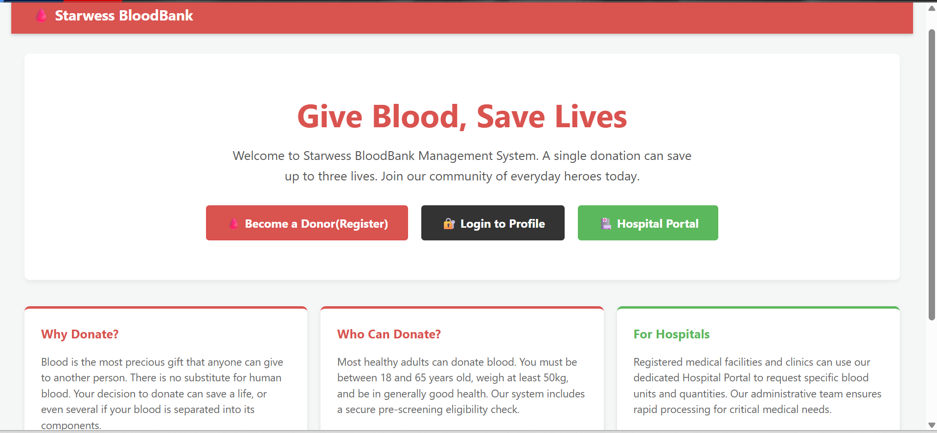
Figure 1 Starwess BloodBank Home Page Interface

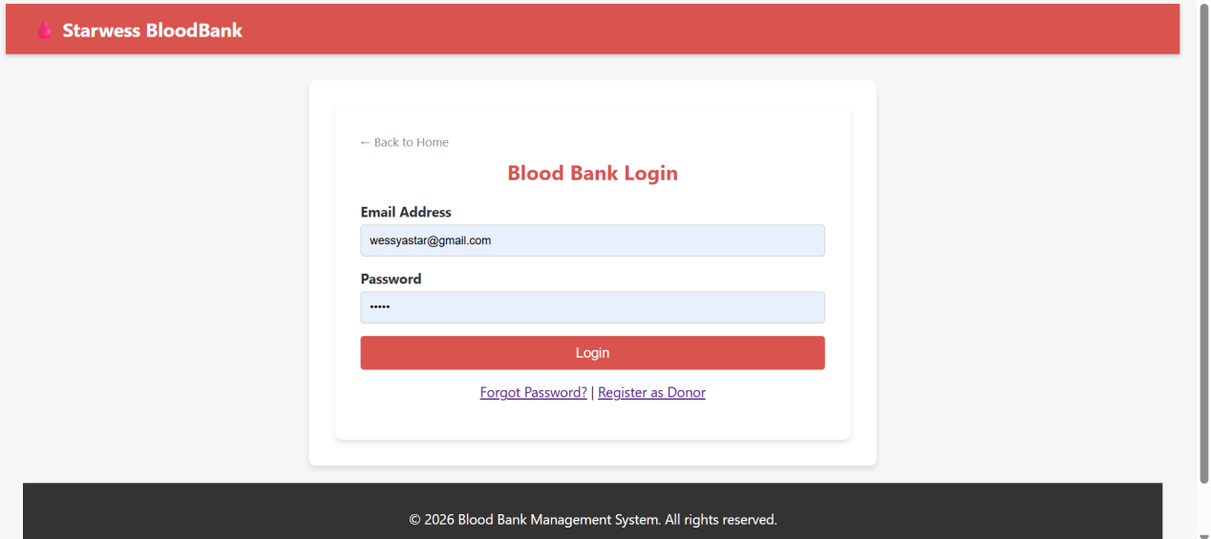Figure 2 User Authentication and Login Interface

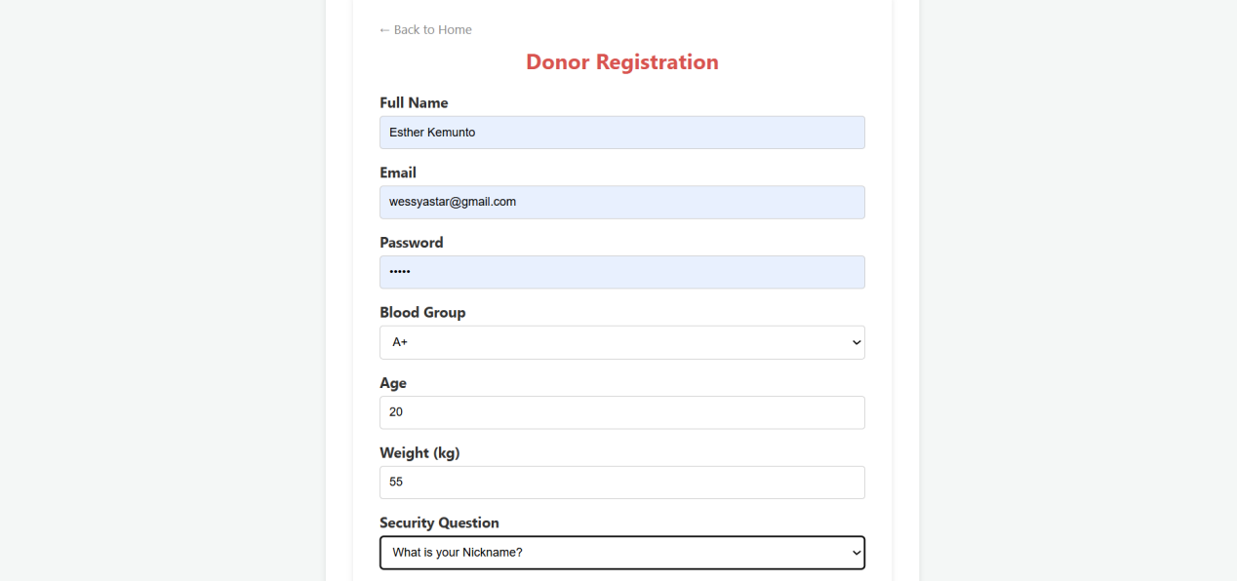Figure 3 Donor Registration and Eligibility Form

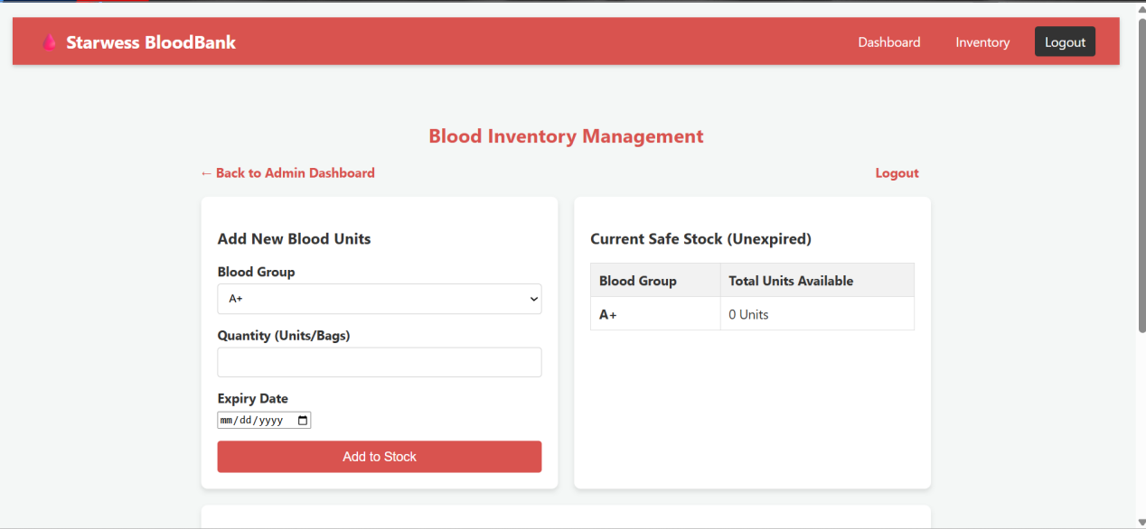Figure 4 Administrative Blood Inventory Management Dashboard
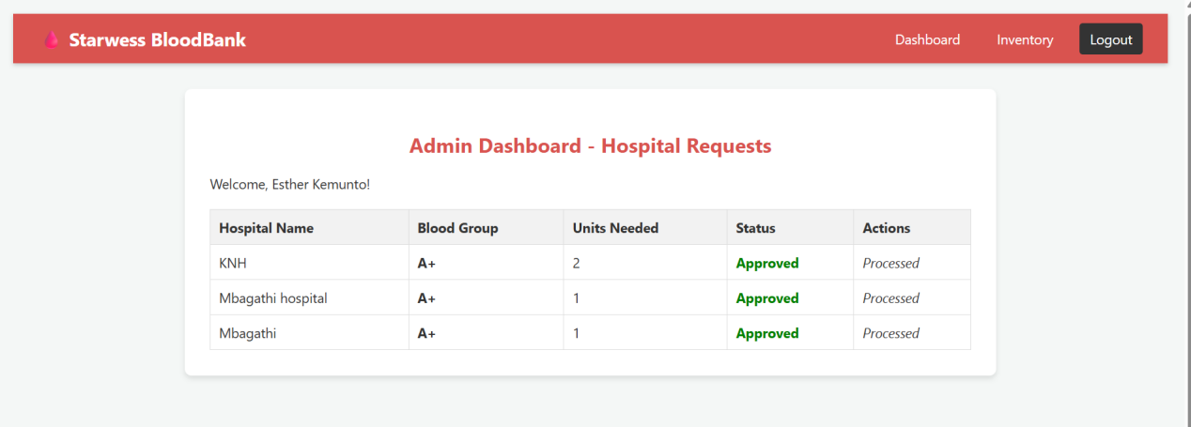Figure 5 Admin Dashboard - Hospital Requests and Approval Tracking

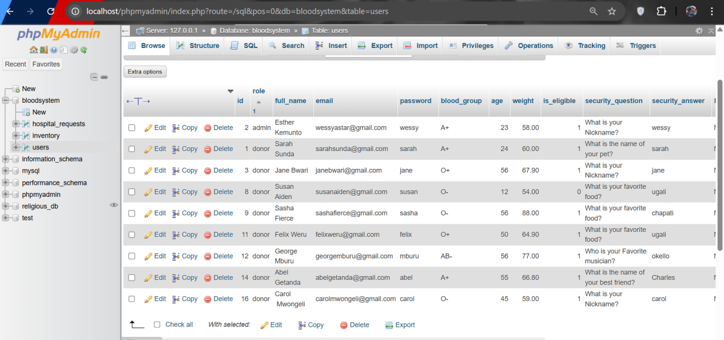Figure 6 Database

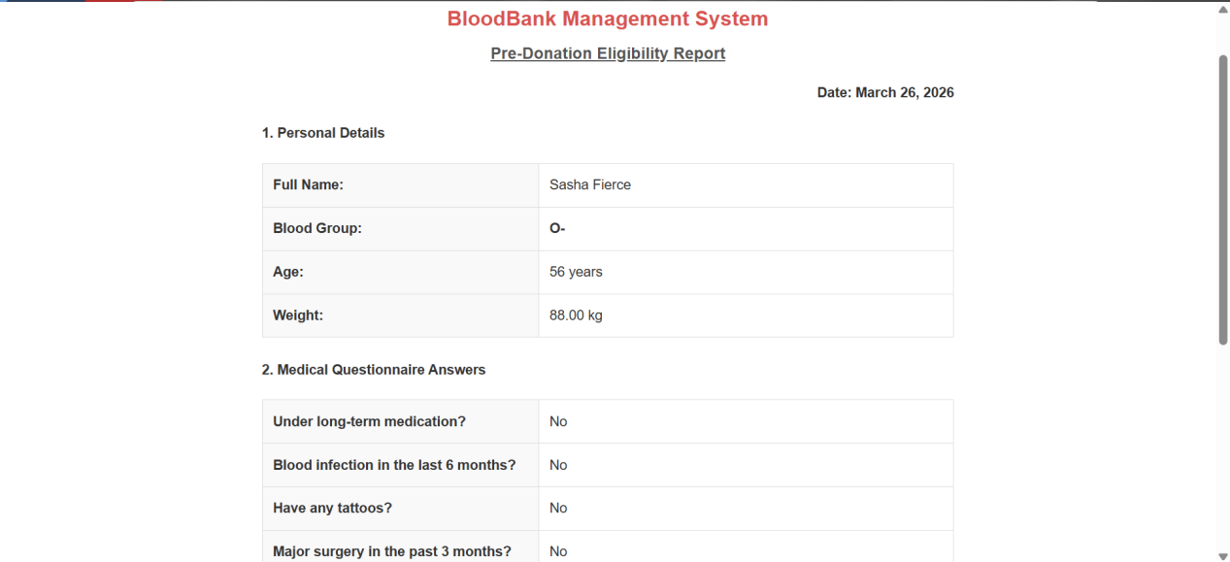
Figure 7 Pre-Donation Eligibility and Medical Screening Report
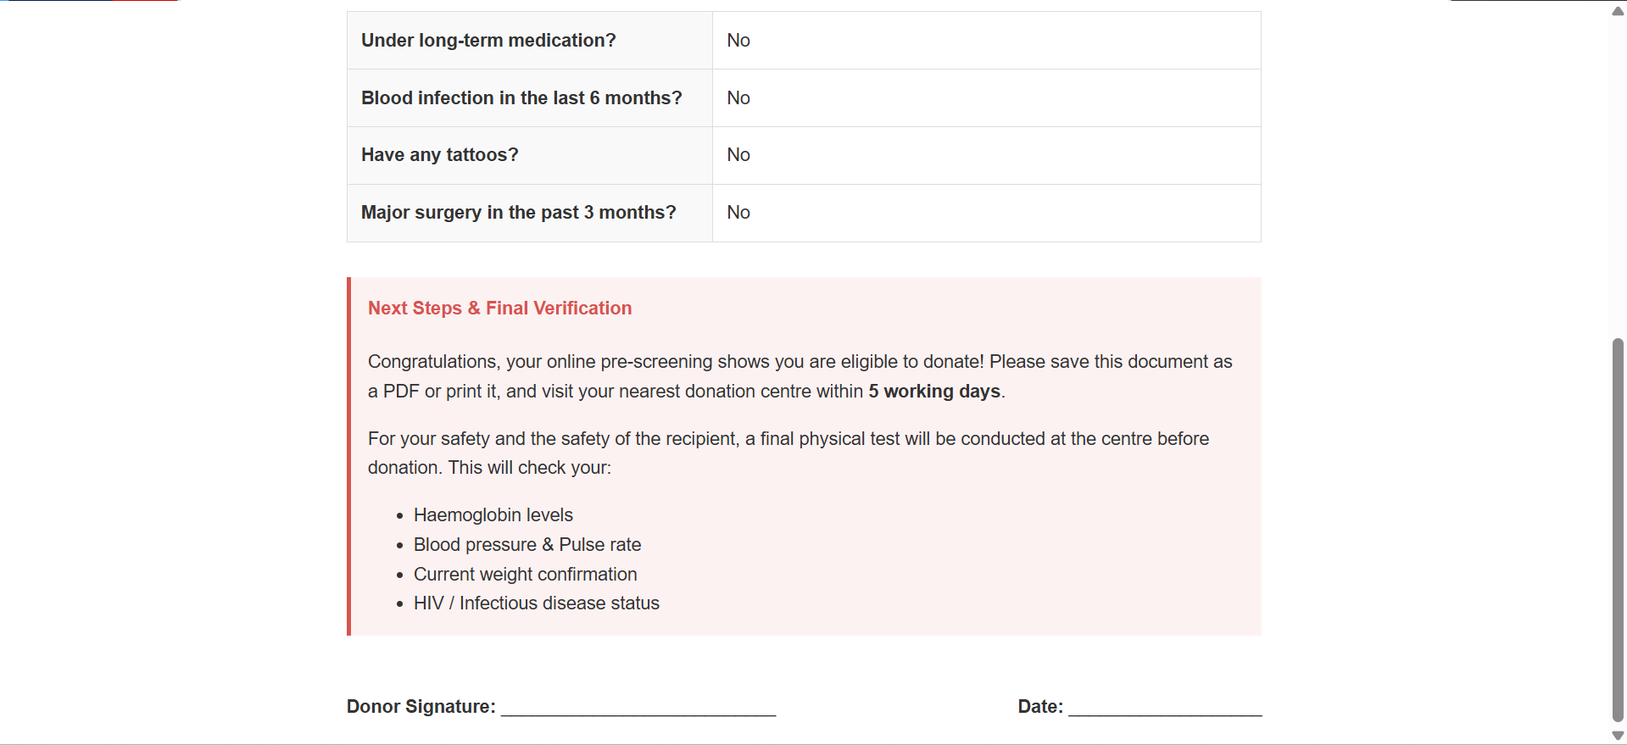Figure 8 Pre-Donation Eligibility and Medical Screening Report

4.3 Testing of the system
The testing phase was conducted to verify that the Blood Bank Management System operates accurately, securely, and efficiently. Various testing methodologies were employed to ensure that the system meets the specific objectives of capturing donor details and monitoring blood inventory

4.3.1 Unit Testing
Unit testing focused on the smallest components of the software to ensure each function performed as expected.Donor Registration: Verified that personal details, blood type, and eligibility status are correctly captured in the database.Login Authentication: Tested the Security Module to ensure only authorized users can access the system through verified account Inventory Updates: Confirmed that the system accurately updates blood quantity and expiry dates when new units are added

4.3.2 Integration Testing
Integration testing was performed to confirm that all individual modules Donor Management, Blood Inventory, and Hospital Request work seamlessly together without errors.Workflow Validation: Verified that a hospital request triggers a status change in the Blood Inventory Module upon approval.Alert Synchronization: Ensured the Notification Module correctly sends SMS or email alerts via Twilio or Africa’s Talking APIs when a donation is scheduled or an urgent request is made

4.3.3 User Acceptance Testing (UAT)
UAT involved actual hospital staff and blood bank administrators who evaluated the system’s usability and accuracy in real-world scenarios.Usability Feedback -Users assessed the interface for ease of navigation, especially for those with limited technical skills.Functional Accuracy-Staff confirmed that the system effectively tracks blood expiry to reduce wastage and allows for timely approval or rejection of blood requests.

4.3.4 Security Testing
Security testing was conducted to identify and resolve potential vulnerabilities.Data Privacy: Validated that donor and patient records are protected through encryption and role-based access control.Access Control: Confirmed that unauthorized users are blocked from sensitive administrative functions to comply with healthcare data regulations

CHAPTER FIVE: SUMMARY

5.1 Conclusion
The development of the Blood Bank Management System successfully addresses the critical inefficiencies associated with manual, paper-based record-keeping in healthcare facilities. By transitioning from outdated methods to a secure, web-based platform, the system fulfills its primary objective of enhancing the efficiency of blood donation, storage, and distribution processes. The implementation of automated donor registration and inventory monitoring effectively reduces the risks of redundant data entry and slow record retrieval while ensuring that safe blood is available for emergency surgeries and treatments. Furthermore, the integration of mobile notification capabilities via SMS alerts bridges the gap between blood centers, hospitals, and donors, allowing for timely approvals of blood requests and improved donor engagement.

5.2 Problems encountered
During the development and testing of the system, several technical and operational challenges were identified that provided insight into the complexities of digitizing healthcare records. Establishing a reliable connection with third-party SMS gateways, such as Twilio or Africa’s Talking, required extensive testing to ensure that alerts reached donors regardless of fluctuating network coverage. Additionally, implementing robust encryption and role-based access control presented difficulties in balancing high security standards with system performance. The reliance on stable internet connectivity was also noted as a potential limitation for facilities operating in regions with inconsistent digital infrastructure.

5.2.1 Technical Challenges
The development process encountered several technical hurdles, particularly in establishing stable connections between the Python (Flask) backend and third-party APIs like Twilio or Africa’s Talking. Managing real-time data synchronization within the MySQL database for donor, inventory, and hospital modules required complex transaction handling to ensure accuracy. Additionally, balancing high-level encryption and role-based access control with system performance was a primary concern during the implementation of the security module. Finally, creating the automated logic for tracking blood units by expiry date and quantity proved intricate, requiring rigorous testing to ensure the system effectively reduced wastage

5.2.2 Operational and Scope Limitations
The implementation of the system revealed several operational constraints, primarily the requirement for stable internet connectivity to access the web-based platform, which remains a challenge in regions with unreliable digital infrastructure. Access is strictly limited to authorized personnel, which, while securing data, restricts the system's utility in broader, public-facing health operations. Furthermore, the scope of the study was limited to administrative data management; it does not handle the physical logistics of blood transportation, delivery tracking, or the complex laboratory testing required for blood units. These boundaries mean that while the system significantly improves donor and inventory record-keeping, it must be integrated with external manual or digital processes to manage the full lifecycle of blood transfusion services

5.3 Recommendations for Future Work
To enhance the system, future development should integrate GPS tracking to address current limitations in monitoring blood transportation and physical distribution. Incorporating automated laboratory testing modules would further bridge the gap between administrative data management and clinical blood screening.Additionally, implementing predictive analytics could help forecast blood demand, while an offline synchronization mode would improve accessibility in areas with unstable internet connectivity. Finally, expanding the mobile application to include a dedicated donor interface would boost engagement by allowing donors to track their history and book appointments directly.

5.3.1 Development of a Mobile Application
Expanding the current web-based platform into a dedicated mobile application would significantly increase accessibility and donor engagement. While the current system includes mobile-integrated communication like SMS alerts , a native app would provide donors with a personalized interface to track their donation history, check real-time eligibility status, and book appointments directly. For healthcare staff, a mobile application would allow for on-the-go inventory monitoring and instant approval of hospital requests, even in environments with limited desktop access. This development would further bridge the gap between blood centers and the community, ensuring a more responsive and efficient blood supply chain.

5.3.2 Automated Blood System and Integration
The transition from manual processes to an automated framework is a primary goal of this study to eliminate human errors and delays in fulfilling urgent medical demands. Integrating the various system modules—including donor registration, inventory monitoring, and hospital requests—ensures that real-time information is shared transparently between all stakeholders. This automation allows for the immediate exchange of data and automatic alerts, which are crucial for better decision-making and preventing avoidable deaths in emergency scenarios.Furthermore, full integration ensures that sensitive medical data remains protected through centralized security measures like encryption and role-based access control. By streamlining these operations into a single, cohesive platform, the system significantly improves coordination between blood centers and healthcare facilities while reducing blood wastage due to expired units.

References
Bashir, f., & Khalid, A. (2019-2020). Exploring the Causes of wastage of Blood and its Components.
P, R., & Kulkarni. (2020). International Journal of Health Information. Blood Bank Automation System, 45-52.
R, P., & Sharma. (2019). International Journal of Applied Research in Social sciences. Health Informatics in Developing Countries.
WHO. (2021). Global status report on Blood safety and availability. WHO.

